Exp No: 4
7 SEGMENT DISPLAY USING AT89C51 USING PROTEUS

AIM:
ite an assembly language program for 7 Segment Display Using AT89C51 using Keil
8/85 and Proteus

SOFTWARE REQUIRED:
Proteus 8 software.

ORG 000H
,#0C0H
ACALL DELAY
ΜOV P2.#OF9H
ACALL DELAY
MOV P2 HOA4H
MOV P2,#0A4H
ACALL DELAY
ΜOV P2,#OBOH
ACALL DELAY
ΜΟν P2,#99Η
ACALL DELAY
ΜOV P2.492Η
ACALL DELAY
ΜΟV P2.#82Η
ACALL DELAY
MOV P2,#0F8H
ACALL DELAY
MOV P2. #80H
ACALL DELAY
MOV P2,#90H
ACALL DELAY
DELAY: MOV R5.#10
HI:MOV R4,#180
H2:MOV R3,#255
H3-DINZ R3H3
DJNZ R4.H2
DJNZ R5,H1
END

OUTPUT:
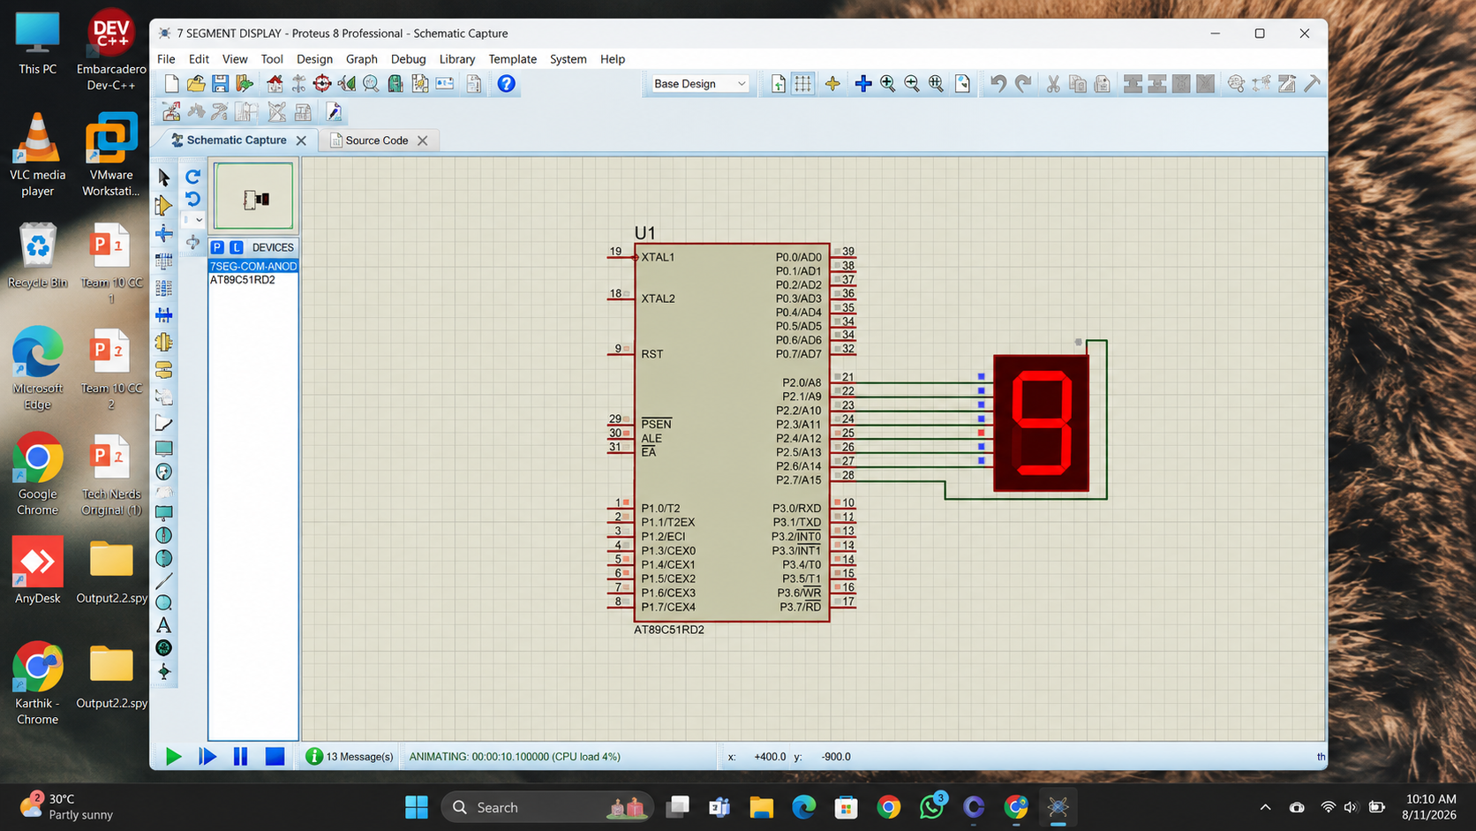

RESULT:

Thus the program has been successfully verified and executed.

